This lambda function aims to print the data of jobTest02.json to CloudWatchLog when json files are uploaded into s3 bucket of jobbuck.

jobTest02.json has the format as below:

[{"_id": {"$oid": "5bbfd5d9dc6546158c8e85c2"}, "title": "Marketing Specialist03", "level": "Mid-Level", "jobType": "Part-time", "publishedDate": {"$date": "2020-11-27T00:00:00Z"}, "deadline": {"$date": "2021-09-23T00:47:51.343Z"}, "effictivePeriod": 300, "jobRequiredDegree": "本科以上", "country": "", "city": ["Melbourne"], "categories_list": ["digital-marketing"]}]

The purpose of this ETL action is to automatically receive data whenever data is uploaded into s3 bucket.

Prerequisite: setup IAM role with AWS S3 full access policy and AWSLambdaBasicE

ExeutionCloudWatchRole

Log in with the IAM role, follow the steps below:

Step One:

* Set up Lambda named s3LambdaFunc02 with permission of AWS S3 ReadOnly access
* Set runtime as Python 3.8
* Copy and paste AWS S3 upload trigger lambda.py to code area
* 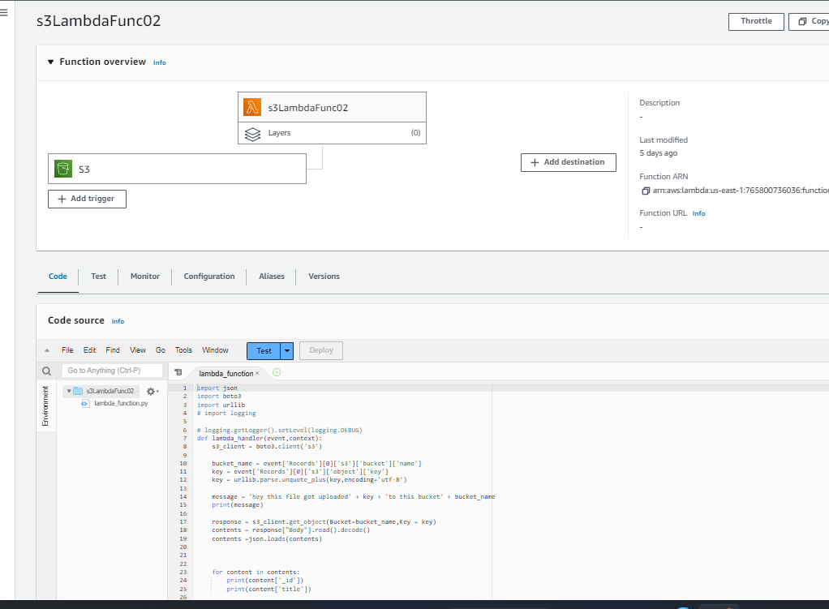
* Figure-1
* Test it
* Save & Deploy

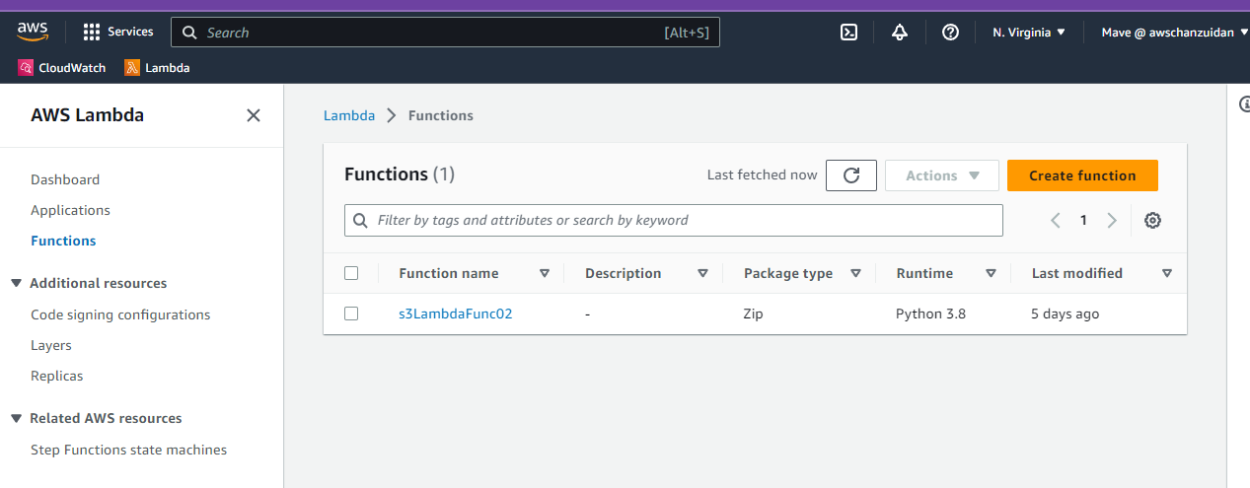

Figure-2

Step Two:

* Create a s3 bucket named jobbuck with Property of Event Notification named s3LambdaEvent02 which has event type of PUT

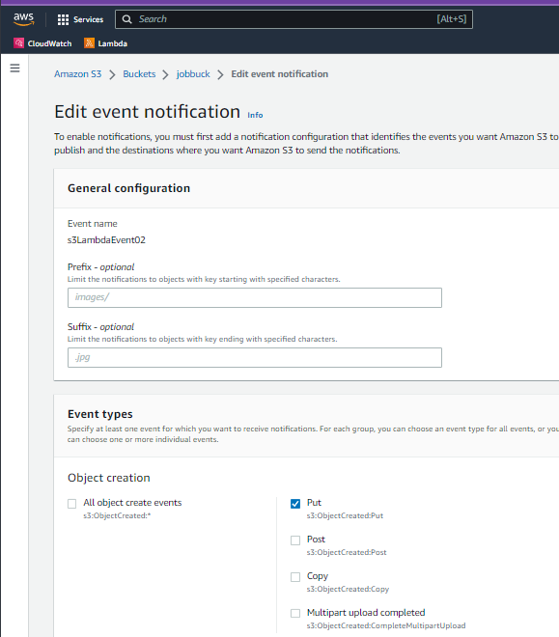

Figure-3

* This event has destination of lambda function : s3LambdaFunc02,
* It means that whenever jobbuck bucket has PUT event ( objects are put into this bucket),
* Will trigger the s3LambdaFunc02 function to execute the python code

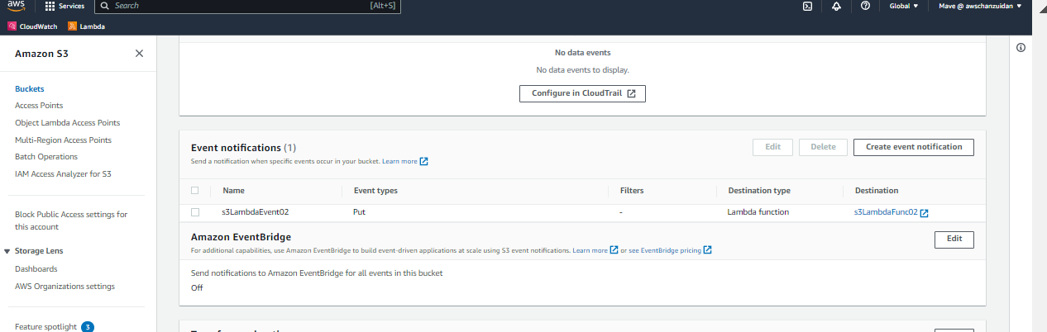

Figure-4

Evaluation the lambda function:

* Go to s3 jobbuck bucket
* And upload jobTest02.json from the local machine

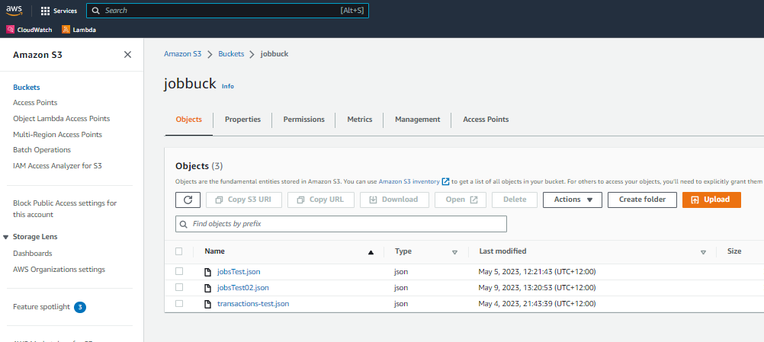

Figure-5

Check with Logger”

Go to CloudWatchLog/ Logs/ Log groups/ /choose aws/lambda/s3LambdaFunc02

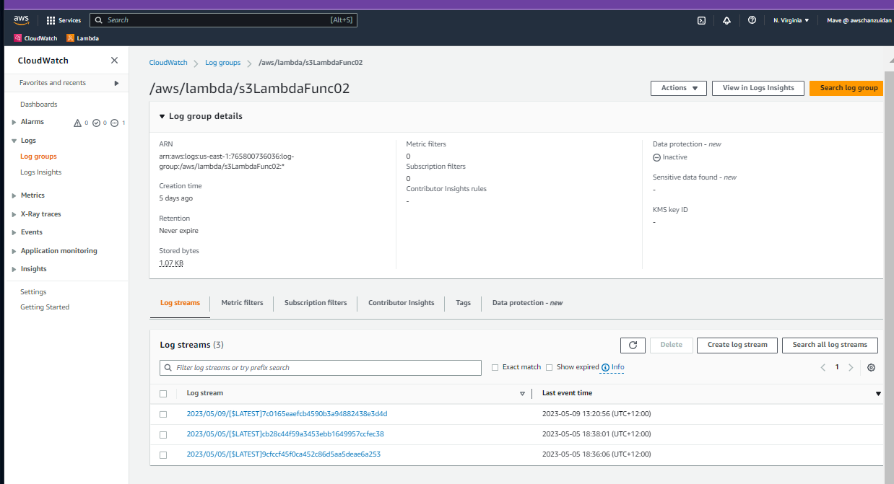

Figure-6

Choose the latest log stream to check

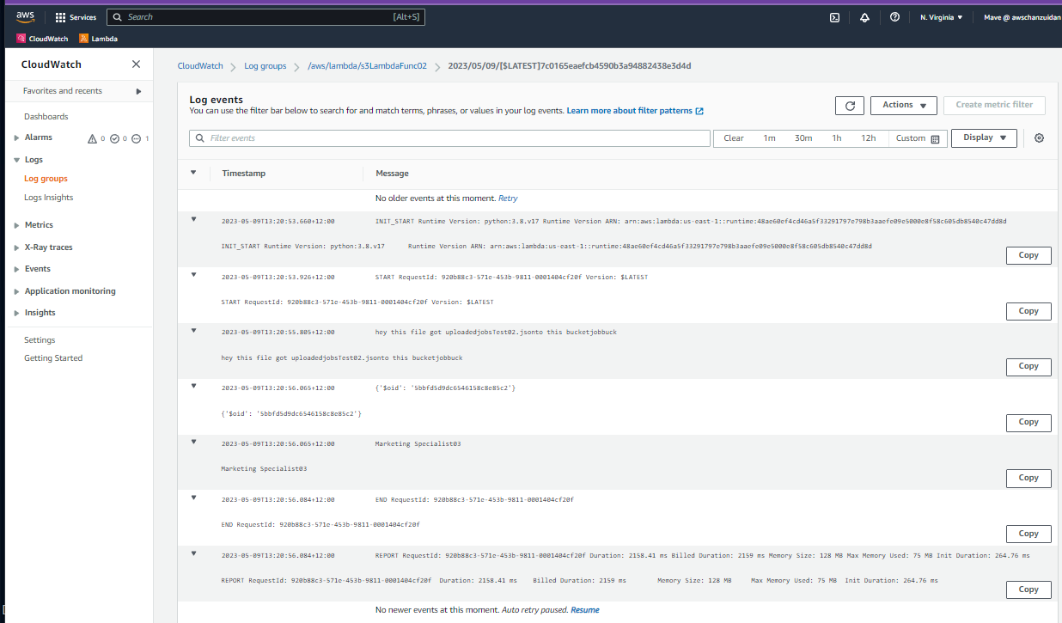

Figure-7

Compared the above logger with the following JSON data,

The answer is: lambda function successfully print the JSON data to log.

[{"_id": {"$oid": "5bbfd5d9dc6546158c8e85c2"}, "title": "Marketing Specialist03", "level": "Mid-Level", "jobType": "Part-time", "publishedDate": {"$date": "2020-11-27T00:00:00Z"}, "deadline": {"$date": "2021-09-23T00:47:51.343Z"}, "effictivePeriod": 300, "jobRequiredDegree": "本科以上", "country": "", "city": ["Melbourne"], "categories_list": ["digital-marketing"]}]